Title of the abstract [centred, bold, Calibri 18pt]
AuthorA¹, Presenting AuthorB^{2,*}, AuthorC³ [centred, Calibri 11pt]
¹DepartmentA, InstitutionAddressA, CountryA. ²DepartmentB, InstitutionAddressB,CountryB.
³DepartmentC, InstitutionAddressC, CountryC. [centred, Calibri, 9pt]
*e-mail: presenting.authorB@murc.ia
Abstracts can be written in Spanish, but take into account that then they will reach people in a reduced area. So, please, consider the possibility to write your abstract in English.
Please use this template to confine the abstract to one A4 page with margins 3 cm (top, bottom, left and right), and the body of the text in Times 10pt justified on both sides. Keep the header or footer of the page blank. The format for references in the text is as it appears in [1, 2], and list them at the bottom of the abstract in Times 9pt. Use 0.5 cm indent in each paragraph.
Formulas can be incorporated in the text, such as $E=\sqrt{p^{2}c^{2}+m^{2}c^{4}}$, or displayed like
$$A=π\int_{a}^{b}{dx e^{-x}f(x)} .$$
Abstracts can contain figures (with caption in Times 9pt), which can be placed in the side of the text (Fig. 1) or centred (Fig. 2). But their location should be optimized considering that the total size of this summary cannot exceed one page.
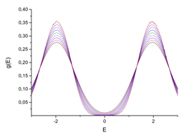
Figure 1. Density of states as a function of energy for several temperatures.
justified at both sides; Calibri 9pt; Insert figure(s) in a frame box, add the caption at the bottom. Don’t forget to remove line colour of the frame.

The abstract must be submitted by April 8, 2022, either in a Word document (if you are reading this document), together with the corresponding PDF file. Before submitting the document, the instructions that appear in red must be removed.
Before submitting the documents, the instructions that appear in red must be removed. Please, don’t use diacritic symbols (like á, í, ñ, ü…) in the names of files/documents, which must be in the form PresentingAuthorSurname-BriefTitle.docx.
Remember that the maximum space for each abstract is only one page.
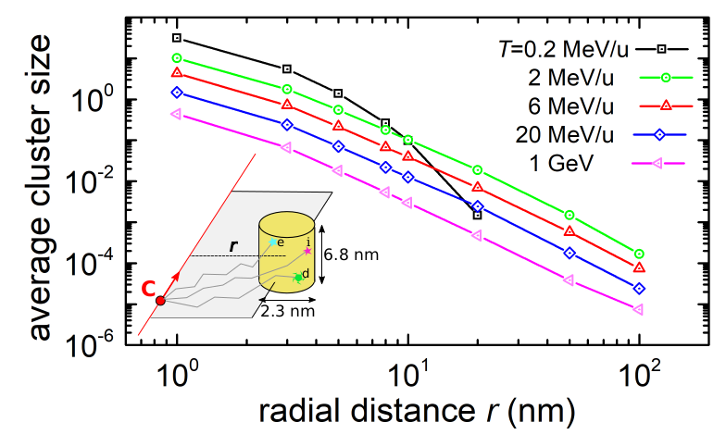
Figure 2. Average cluster size of damaging events in liquid water as a function of the distance from the ion track for different values of the carbon-ion energy.
Blank line, Times 10pt
[1] Authors, Journal volume, page (year).
[2] Authors, Book title, publisher (year).
Blank line, Times 10pt
Acknowledgements: [delete if not applicable]

